**Modern Simplicity with Timeless Circle Mirrors**

When it comes to interior design, small details make a big impact — and **Circle Mirrors** offer the perfect blend of simplicity and sophistication. With their smooth, symmetrical shape, these mirrors bring balance, harmony, and modern elegance to any space. Whether placed in an entryway, bedroom, bathroom, or above a console, circular mirrors create a soft visual break from sharp lines and corners, adding an artistic touch to your décor.

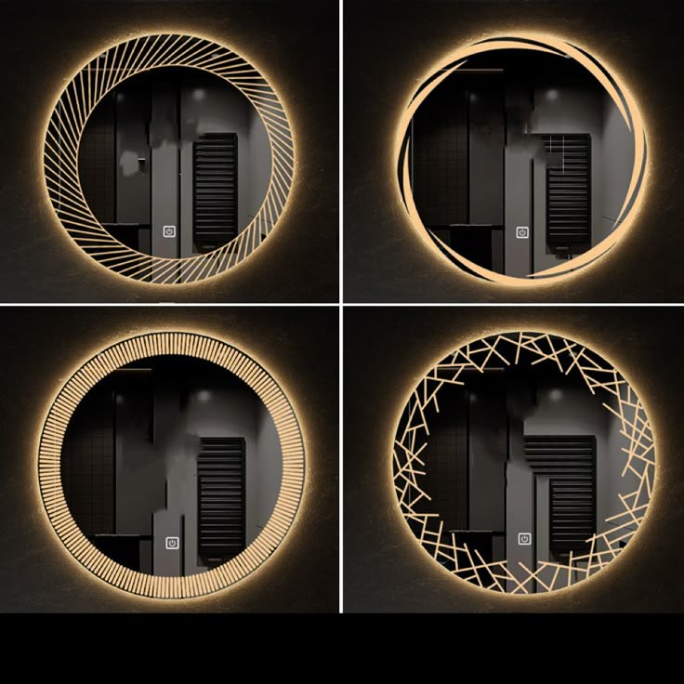Our Circle Mirrors are available in a variety of frame options — from minimalist black metal to warm wood tones or luxurious gold finishes. Each piece is crafted with high-quality, distortion-free glass that ensures clear reflection and long-lasting clarity. Their versatile design allows them to be the centerpiece of a room or a stylish complement to existing wall decor.

Besides being visually appealing, circle mirrors help reflect light and open up spaces, making them ideal for both large and small rooms. Easy to hang and timeless in appearance, these mirrors suit every interior — from contemporary to boho, from Scandinavian to classic.

Add softness, symmetry, and sophistication to your home with a mirror that never goes out of style.